**The World Bank Group Highlights**

* Mission
* Activities
* Profile By The Numbers
* 2015 Statement from President in *World Bank Group A to Z*
* Successes Reported in *World Bank Group A to Z*
* Governance & Structure
* Org Chart
* Recruitment and Talent

**Mission:**

* **End extreme poverty** (no more than 3% people living with less than $1.90 a day. 2011 rate 14.5%)
* **within a generation** (by 2030 – with work to continue beyond that in destitute Fragile and Conflict-Affected Situations)
* **and boost shared prosperity** (promote income growth of bottom 40% of population in each country).

**Activities:**

* Policy and Strategic Advice to countries, and translating evidence to practice
* Promote equity by expanding the pie, not just redistributing existing
* Identification, preparation, appraisal and supervision of development projects
* Galvanize international and national efforts
* Promote environmental, social and fiscal sustainability
* Aim for sustained social inclusion
* Limit size of economic debt inherited by future generations
* Make investments that improve opportunities/jobs, provide safety nets and raise resources to support policies eg tax systems/incentives
* Promote Green Growth - sustainable growth that is efficient and takes into account the social costs of resource depletion. Promoting alternative measures to GDP to monitor eg wealth and natural capital accounting, developing measures of “genuine savings” net of natural capital depletion and pollution damages.

**Profile by the Numbers:**

* 10,000+ employees worldwide
* Locations in 120+ countries
* $65 billion in commitments (loans, grants, equity investments, guarantees to partner countries and private businesses. $44 billion in disbursements.
* Made up of 189 member countries
* 6 languages represented on website (Spanish, French, Russian, Urdu?, Chinese, Japanese)

**2015 Statement excerpt from President, Jim Yong Kim:** (excerpted from *World Bank Group A to Z*)

*Increased collaboration among all four institutions of the World Bank Group made these advancements possible. For the first time in history, we have devised a plan to make the Bank’s different bodies work in tandem…Feature of new strategy is creation of global practices that will spread knowledge across sectors, regions and entire institution [response to past silos preventing shared knowledge and technical skills] to work across diverse expertise areas and geographical locations…Marks a shift from completing projects to one that values delivering solutions. We’re becoming nimble, evidence-based, and financially viable… bend the arc of history toward justice…*

**Successes reported in *World Bank Group A to Z* (2015)**

|  |  |
| --- | --- |
|  |  |

**Governance & Structure:**

* World Bank Group: Five Institutions, One Group

1. **International Bank for Reconstruction and Development:** Lends to govts of middle-income and creditworthy low-income countries
2. **International Development Association:** Provides interest-free loans – called credits – and grants to govts of the poorest countries. (2015 report no longer indicates this institution as a separate entity)
   1. These two institutions above comprise World Bank
3. International Finance Corporation: largest global development institution focused exclusively on the private sector. Helps developing countries achieve sustainable growth by financing investment, mobilizing capital in international financial markets and providing advisory services to business and governments.
4. Multilateral Investment Guarantee Agency: Founded 1988, to promote foreign direct investment into developing countries by offering political risk insurance (guarantees) to investors and lenders.
5. International Centre for Settlement of Investment Disputes: Provides international facilities for conciliation and arbitration of investment disputes

* Like a cooperative, World Bank is made up of 189 member countries, or shareholders, represented by a Board of Governors. Generally represented by ministers of finance or development.
* The World Bank operates day-to-day under the leadership and direction of the president, management and senior staff, and the vice presidents in charge of Global Practices, Cross-Cutting Solutions Areas, regions, and functions.

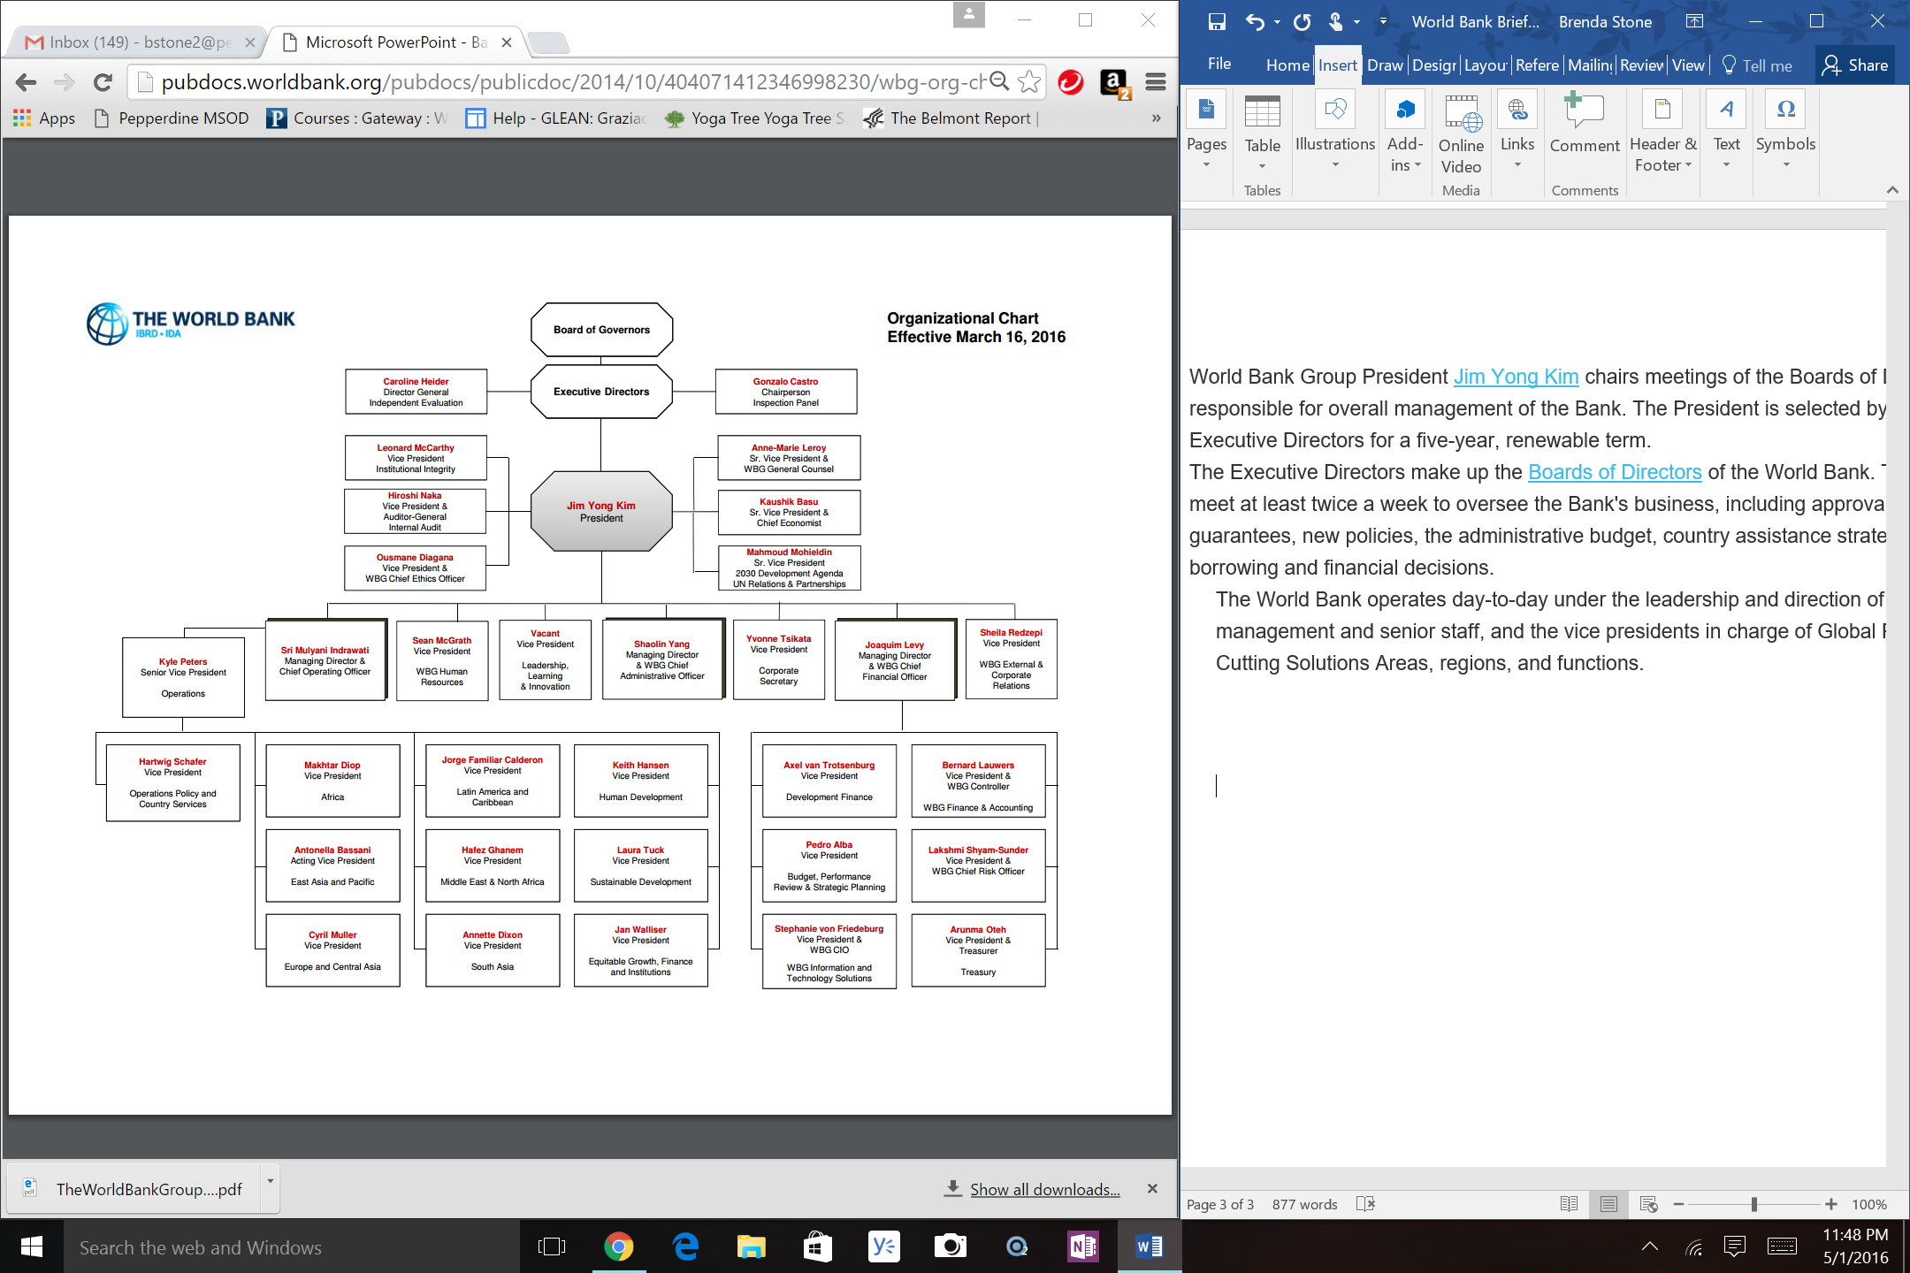

**Recruitment & Talent:**

* Brightest, most talented from around the globe.
* Strong academic background, broad understanding of development issues, international work experience.
* Dedicated, committed workforce that is diverse in gender, nationality and ethnic background (from 170+ countries)
* LinkedIn “Most inDemand Employers”.
* Specialize in economics, finance, education, public health, engineering, and more.
* 40% in offices in more than 110 developing countries.
* Proportion of country-based staff has grown in recent years.
* Competency frameworks and career paths have been defined. Growth-oriented work environment.
* Values quality of life externally and internally