 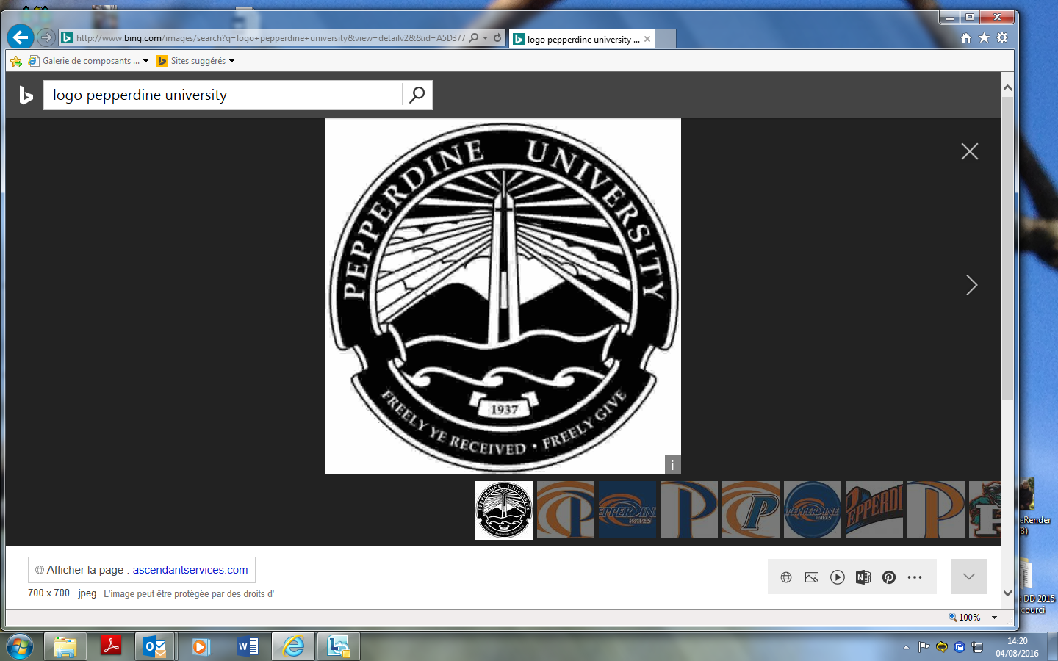

**“Flash Consulting” dealt by the students of Pepperdine University – California**

The aim of this consulting is to assess the action of the Sustainable Development Mission within the City of Lyon administration and for its local civil servants.

INTERVIEW : Mr / Mrs ………. / Direction …..

Date :

1. **Could you assess your satisfaction regarding the services the Sustainable Development Mission give you ?**

Very satisfactory / satisfactory / No opinion / Not satisfied / displeased

Comments :

1. **Could you assess your satisfaction regarding the time the Sustainable Development Mission takes when you request its services ?**

Very satisfactory / satisfactory / No opinion / Not satisfied / displeased

Comments :

1. **What would you expect from the Sustainable Development Mission ?**

→ What should it stop doing ?

→ What should it start doing ?

→ What should it go on doing ?

→ What would you suggest in order to improve the services given by the Sustainable Development Mission ?

Comments :

1. **What should be done in order to improve the Sustainable Development Mission governance ?**

WIKIPEDIA: “Environmental governance is a concept in [political ecology](https://en.wikipedia.org/wiki/Political_ecology) and [environmental policy](https://en.wikipedia.org/wiki/Environmental_policy) that advocates [sustainability](https://en.wikipedia.org/wiki/Sustainability) ([sustainable development](https://en.wikipedia.org/wiki/Sustainable_development)) as the supreme consideration for managing all human activities—political, social and economic. Governance includes government, business and civil society, and emphasizes whole system management.”

→ In creating more transversal working groups ?

→ On which themes ?

→ On an external / Internal basis ? Mixing internal and external partners ?

→ Would you like to get involved ?

→ Through internal / external consulting ?

→ Should the Sustainable Development Mission work more intensely with the external stakeholders, through the organization of events, articles, workshop, forums, etc.?

→ How should the Sustainable Development Mission improve the reporting of its actions ?

→ What could you imagine to improve the report dealing with sustainable development for the City of Lyon ?

Comments :

1. **Other suggestions**

Thank you for your help !